
Workflow: 3D City Asset Editing
Version: 1.0 beta
Date: April 5, 2013

Introduction
This workflow explains how to create and maintain some of the basic building blocks of a 3D City: buildings and trees. The primary steps include:
- Creating raster surface models (DTM, DSM & nDSM) from classified LiDAR data
- Obtaining heights of building footprints, and heights and crown widths of city trees
- Obtaining base elevations of building footprints
- Burning building footprint elevations into the terrain surface

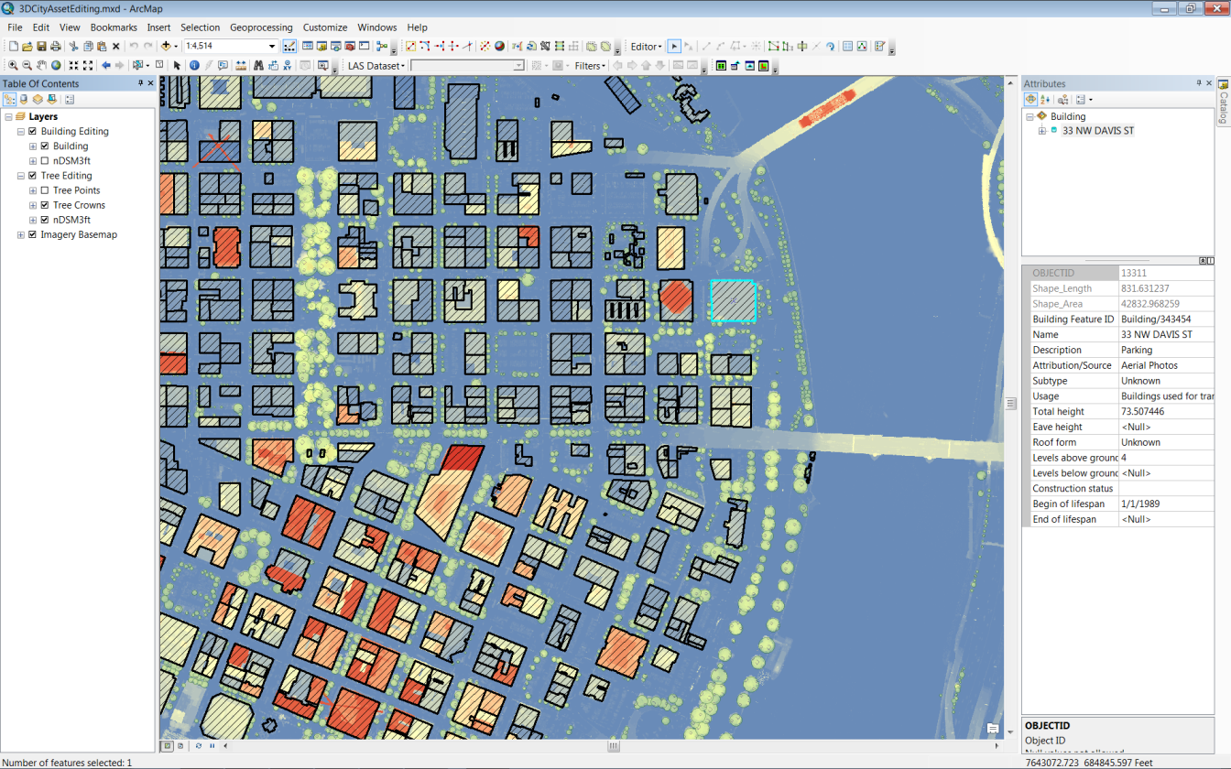
Asset Editing map for creating and deriving heights of buildings and trees

Requirements to execute this workflow:
Software:
- ArcGIS 10.1 SP1
  - 3D Analyst extension
  - Spatial Analyst extension
- CityEngine 2012.1
Data:

- A localized 3D City geodatabase (3DCity.gdb). Use the models and tools in the Data Management workflows (#1 & #2) to configure and import features or regulations into a 3D City geodatabase. Or, just use the provided sample data for the city of Portland in \Samples\Portland\3DCity.gdb
- An AssetEditing.gdb geodatabase containing raster surfaces and features to “3D-enable” building footprints and trees. (Download the Portland AssetEditing.gdb here and install it in the \Apps\3DCityAssetEditing\ folder of the template)
- Classified LiDAR data for your city. LiDAR-derived raster surfaces for Portland are supplied in the above AssetEditing.gdb, but to follow the raster processing steps used to create them (Part 1 below), a portion of the 2007 LiDAR data for the city of Portland can be downloaded from the NOAA data viewer. Zoom to the downtown Portland area, select the “Draw Area” option at the top and add the 2007 Oregon Department of Geology and Mineral Industries LiDAR to your Cart. At checkout, enable the following output options:

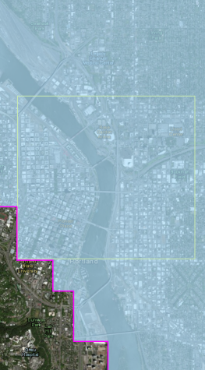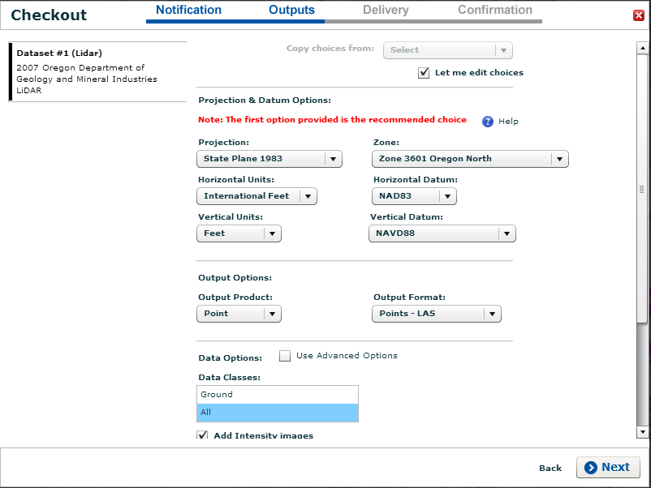

Part 1: Create raster surfaces from your classified LiDAR data

A fundamental component of any 3D map is a detailed terrain model. This provides “texture” for the city scene, but also determines the vertical placement of all the ground-based GIS data: buildings, land cover, street furniture, and other installations. To obtain the level of accuracy required for realistic terrain modeling and feature placement at the street-level, high resolution classified LiDAR data is required.
For the purpose of terrain modeling and feature extraction, there are three basic surface types used in the 3D City templates. These raster surfaces are created based on different return classifications in the LiDAR dataset:
- Digital Terrain Model (DTM) – A raster representing the elevation of the bare earth, with structures and vegetation removed. This is used as the base elevation surface in the 3D scenes (ArcGlobe, ArcScene, CityEngine). Ground return points are used.
- Digital Surface Model (DSM) – A raster representing the elevation of all structures and natural features on the earth. The same kind of surface you’d get if you “shrink-wrapped” the landscape. First return points are used.
- Normalized Digital Surface Model (nDSM) – This surface is used to model the height above the ground surface of structures and vegetation. The difference between a DSM and a DTM (DSM – DTM = nDSM).
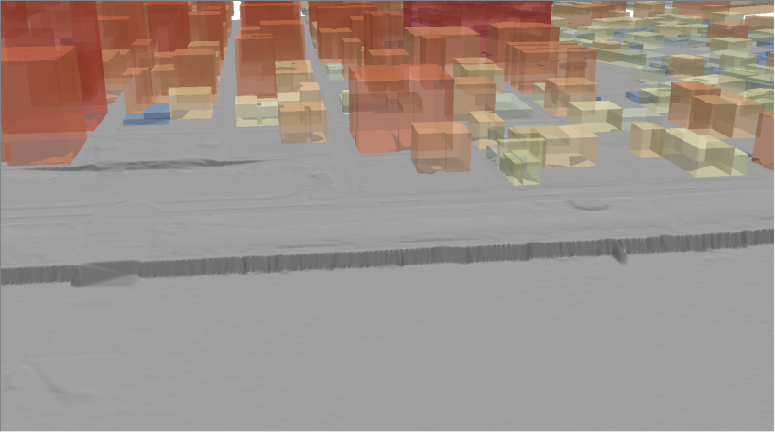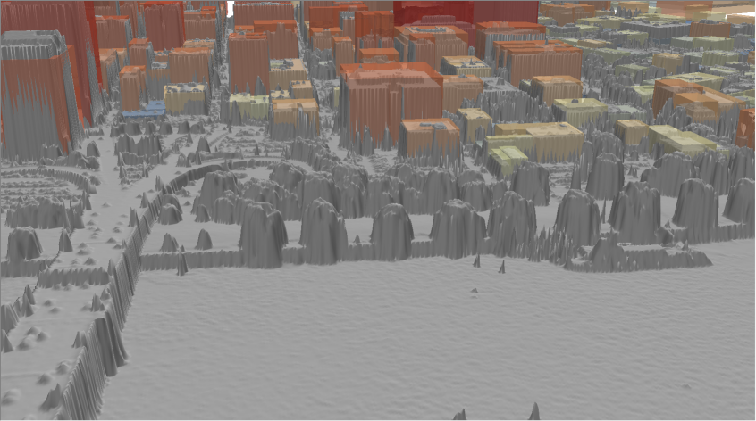
Digital Terrain Model (left) and Digital Surface Model (right) along the riverfront with extruded building footprints
Using the LAS Dataset tools in ArcGIS 10.1, it is a simple process to convert high resolution LAS data into these 3 surfaces: DTM, DSM, and nDSM. (See the ArcGIS online help topic on using the LAS Dataset toolbar.)
- Create a new LAS Dataset in ArcCatalog, load your LiDAR (*.las) files, set your spatial reference according to your LAS metadata, and check point spacing statistics. (Under ~3ft/~1m is recommended for this workflow)
- Open the LAS Dataset (*lasd) in ArcMap and create a DTM using LAS Dataset point classification filter:
  - Select Ground Returns in the LAS Dataset toolbar in ArcMap
  - Run the LAS Dataset to Raster GP tool:
    - Value Field: ELEVATION
    - Triangulation: NATURAL_NEIGHBOR, NO_THINNING
    - Sampling Value: 3 feet (or ~2x average point spacing for your own data)
- Create a DSM using LAS Dataset point classification filter:
  - Select First Returns in the LAS Dataset toolbar in ArcMap
  - Run the LAS Dataset to Raster GP tool:
    - Value Field: ELEVATION
    - Binning: MAXIMUM, NATURAL_NEIGHBOR
    - Sampling Value: 3 feet (or ~2x average point spacing for your own data)
- Subtract the Ground Surface from First Return surface to create a nDSM surface:
  - Run the Minus GP tool to output a new nDSM raster
    - Raster #1: DSM from Step 3 above
    - Raster #2: DTM from Step 2 above

The output, a normalized Digital Surface Model (nDSM, above) is used to calculate feature heights (red=higher)

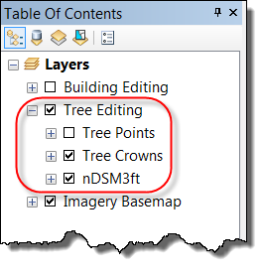
Part 2: Create trees with height and crown dimensions

First, ensure the Attribute Assistant add-in is installed. Simply double-click the AttributeAssistant.EsriAddIn in the \App\3DCityAssetEditing\AttributeAssistant folder of the template download and complete the installation. The Attribute Assistant uses a DynamicValue and GenerateID table with some pre-defined methods to automatically generate attribute values and unique IDs during the editing process. For more information on how the Attribute Assistant works, refer to the entry in the ArcGIS Online Help.

To begin, open the AssetEditing.mxd editing map located in the \App\3DCityAssetEditing folder, and ensure the Attribute Assistant add-in is installed and active: 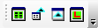 Turn on the Tree Editing and Imagery Basemap group layers (disabling the Building Editing & Land Use Editing group layers), and begin an editing session on the Tree Crowns feature. Open the “Tree Editing” bookmark.
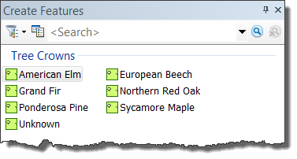
In the create feature pane on the right, select one of the example tree types (the tree types can changed or customized for your location) and select the circle construction tool. Zoom into an area with trees and drag the circle so that it completely encompasses the extent of the tree crown. Repeat this process until you’ve sketched in all the trees for your area of interest. Save and end the editing session.

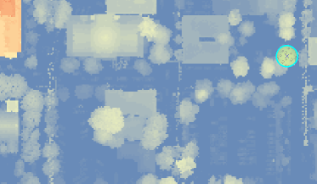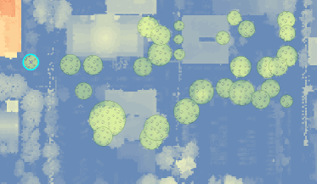
Placing tree crown features using the nDSM raster as a guide

Next, run the GP model Calculate Tree Heights in the 3DCityAssetEditing toolbox (Note: you will need to set your current workspace in the ArcMap document’s Environments… settings and the GP model’s Properties… to the top directory of the 3D City template were the \Apps, \Samples, \Workflows, etc. folders are located).

The Calculate Tree Heights GP model does the following:
- The tree crown diameter is calculated from the area of the tree crown circle
- The tree height is calculated based on the maximum value in the nDSM raster within the Tree Crown circle (Zonal Statistics is run on a slightly smaller circle to reduce the chance of calculating the height of an adjacent building)
- A generalized tree shape is calculated based on the ratio of the crown diameter to the tree height:
  - Trees that are roughly equal in diameter and height are spherical
  - Trees that are taller than they are wide are ellipsoid
  - Trees that are wider than they are tall are other (or “spreading”)
- Trees shorter than 5 feet tall are thrown out
- The tree crown width, height, and shape attributes are loaded into the 3DCity.gdb as new Tree point features

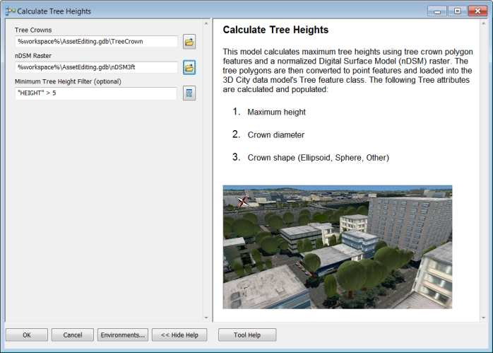

These tree points can now be visualized using the 3DCityViewer.3dd ArcGlobe document located in the \Apps\3DCityViewer\ folder as 3D symbols with realistic height and crown width dimensions.
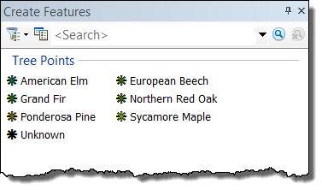
Using the Attribute Assistant add-in, a simpler editing approach can be used if you only wish to obtain tree heights and do not need crown width information. In this situation, start an edit session and directly use the 3D City Tree Point feature instead of the Tree Crown polygon.
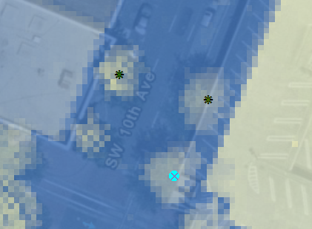
- Place a point from the create feature template at the center of the tree “hot spot” on the nDSM raster.
- The Attribute Assistant will run a raster intersection method on the nDSM (below image) and add the height value of that pixel to the tree height attribute. (Note that this is intersecting the tree location with a single pixel of the nDSM, so it may not necessarily represent the maximum height of that tree, depending on where the point is placed.)
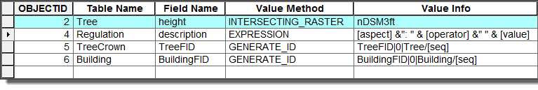
Part 3: Create building footprints with maximum heights
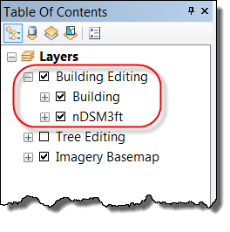
Similar to the tree editing steps above, this workflow uses the normalized Digital Surface Model (nDSM) to determine the maximum heights of building polygons.

To begin, open the AssetEditing.mxd editing map located in the \Apps\3DCityAssetEditing\ folder. Activate the Building Editing and Imagery Basemap group layers (disabling the Tree Editing & Land Use Editing groups), and begin an editing session on the Building polygon feature. Open the “Building Editing” bookmark.

In the create feature pane on the right, select the Building polygon and the appropriate shape type – for buildings, typically a Rectangle or Polygon. Sketch in the building footprint based on the outline in the nDSM raster. The Attribute Assistant will automatically populate a sequential Building Feature ID for each footprint added to the map.

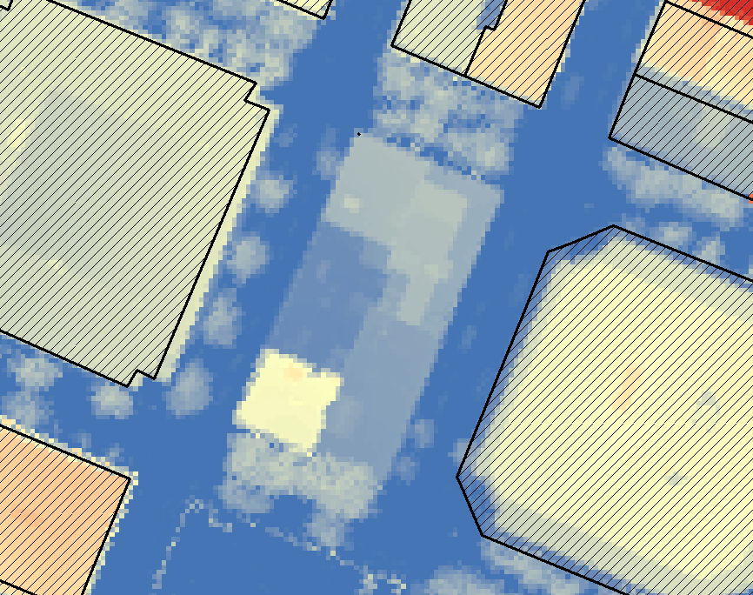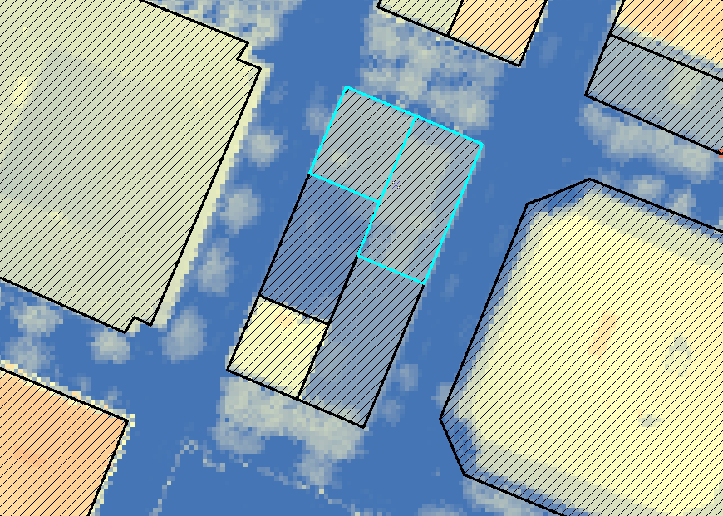

Similar to the GP model that is used to determine tree heights, the Calculate Building Heights model in the 3D City Feature Maintenance toolbox calculates the height of the building based on the maximum nDSM value (Note: with this and other tools in this workflow, you will need to set your current workspace in the ArcMap document’s Environments… settings and the GP model’s Properties… to the top directory of the template where the \Apps and \Samples folders are located.)

The GP model does the following:

- A default negative buffer of 6 feet is applied original building footprint. Similar to the tree model, this reduces the chance of pixels from a neighboring building influencing the maximum height calculation.
- The building height is then calculated using according to the building centroid’s intersection with the zonal statistics maximum value in the nDSM raster.
- The height value is written to the 3DCity.gdb Building feature’s totalHeight attribute.
(Note: The GP tool only writes a value to the totalHeight attribute if it is <Null>. If there is an existing totalHeight value, it will not be overwritten.)

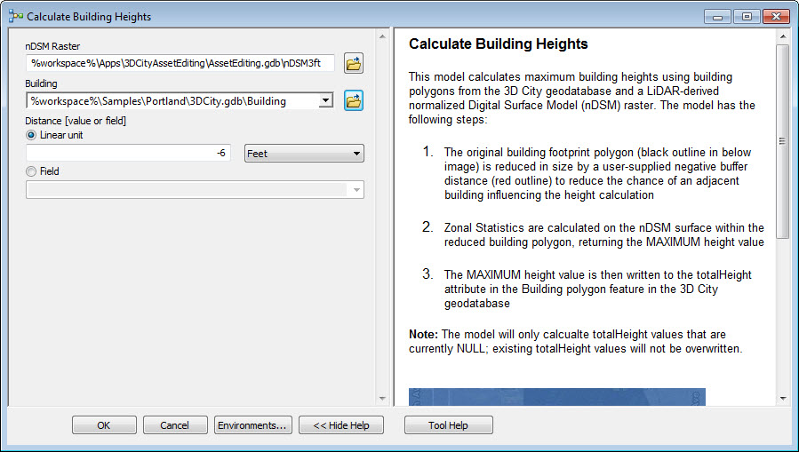

Part 4: Calculate base elevations of building footprints

To situate the Z value of the building footprints and footprint-derived multipatch volumes to the correct base elevation, the Digital Terrain Model (DTM) created in Part 1 is used.

Once the city’s building footprints have been imported or created, run the Calculate Building Base Elevations tool in the 3D City Asset Editing toolbox. This tool uses zonal statistics to calculate the elevation value of the DTM within each footprint, using one of three user-selected options:

- Minimum: the minimum value within the footprint is applied as the polygon’s Z-elevation
- Mean: the mean value within the footprint is applied as the polygon’s Z-elevation
- Maximum: the maximum value within the footprint is applied as the polygon’s Z-elevation

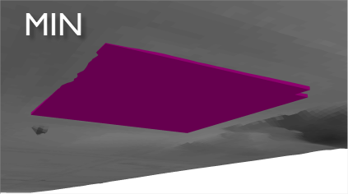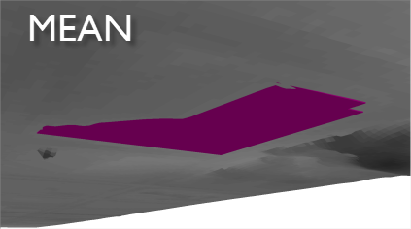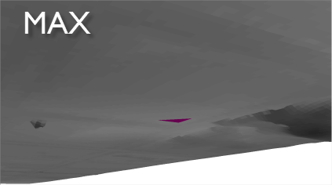

Three different options for determining the building footprint base elevation (looking at an extruded footprint from below the DTM surface)

Run the Calculate Building Base Elevations GP tool and specify the following parameters: DTM surface, Building footprint and Statistics type (minimum, mean, or maximum):

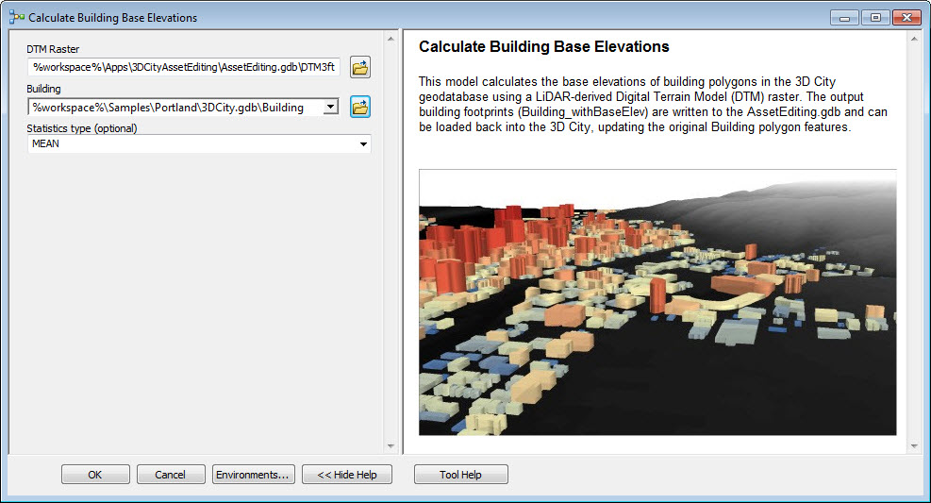

The Calculate Building Base Elevations model outputs a copy of the Z-enabled Building polygons to the AssetEditing.gdb. After the GP model has finished, open the Building_withBaseElev feature in ArcScene to ensure the footprints are set at the correct elevations, then replace the existing Building polygons in the 3DCity.gdb with the updated and Z-enabled features.

Part 5: Burn building footprint elevations into the terrain surface

As a last enhancement to the terrain surface, the base elevations of the building footprints can be “burned in” to the DTM raster. This ensures that the base of each 3D building will sit flush with the ground surface, reducing the amount of the building that might be “buried” in the terrain on the upslope – or have a gap on the downslope.

To add the building footprints as adjustment surfaces, open up the LAS dataset you created in Part 1, Step 1. Navigate to the Surface Constraints tab and use the “Add…” button to select the Building polygons in the 3DCity.gdb that have been Z-enabled in Part 4, above. In the drop-down menus, select Shape for the height source, and Hard Replace for the surface feature type:

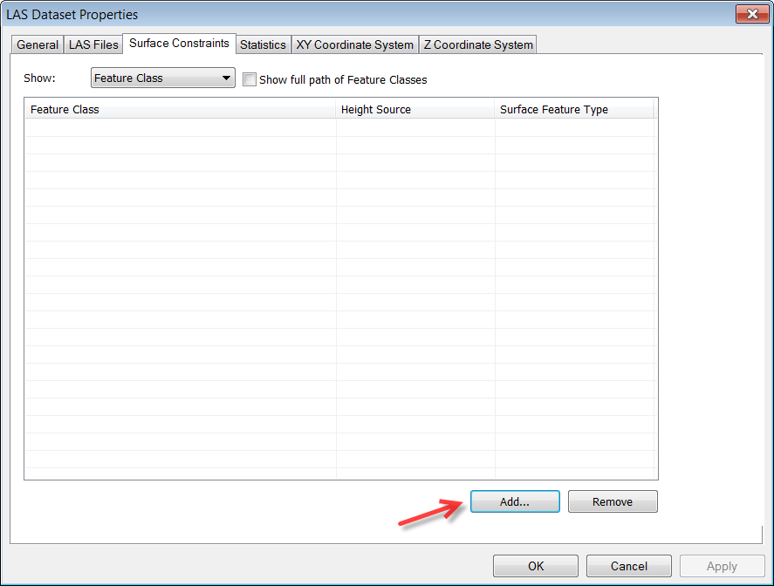
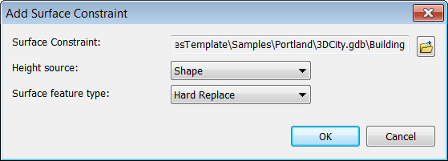
Close the LAS Dataset Properties window and revisit Part 1, Step 2 to create a new DTM surface to replace the old. For comparison, here is the DTM raster before and after the building footprint elevations have been “burned in”:
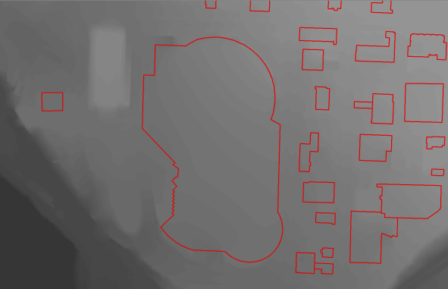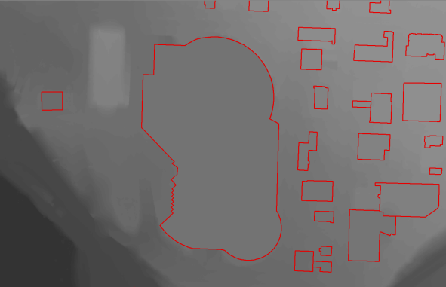
Original DTM (left) and DTM with surface constraints (right) has flattened out the terrain gradient inside buildings.
Workflow: 3D City Asset Editing
Version: 1.0 beta
Date: April 5, 2013

Release Notes
The April 5, 2013 release is the second release of the 3D City Asset Editing workflow for ArcGIS 10.1

New Functionality

N/A

Resolved Problems

N/A

Known Issues

N/A

